CS4650

Assignment 4B: Segmentation of Structures of Interest

Alexander Kochman

October 27, 2024

**Image 1**

Original Image Preprocessed Image (Gaussian, sigma=1, gray)

K-means Clustering Output Binarized Mask

Preprocessed Image (Gaussian, sigma=1, RGB)

K-means Clustering Output Binarized Mask

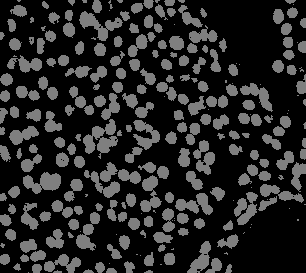

Discussion

The results of this application of the k-means clustering method are satisfactory because they achieve nearly a perfect segmentation of cells from the background for this image. The gray feature was slightly better than the RGB channel feature, but both produced usable results. The RGB feature likely had more pixels in the background that resembled a pixel within a cell because the color of the background is similar to that of the cells, but in the gray image the cells are all generally more intense than the background.

**Image 2**

Original Image Preprocessed Image (Median, 5x5 window, gray)

K-means Clustering Output Binarized Mask

Preprocessed Image (Median, 5x5 window, RGB)

K-means Clustering Output Binarized Mask

Discussion

In this image, k-means clustering did not achieve a satisfactory result. The gray and RGB images alike had most cells connected with other cells when they were meant to be segmented. This would create a large margin of error in any application on the image from the binarized mask, such as an area of cells calculation. Both the gray and RGB application struggled to separate the darker purple cells from the pink cells, which created many false positives.